

**Assessment 4**

Student ID:- 11824604

Name:- Niloy Chandra Das

Contents

Selection of Company 4

Introduction 4

Interface Design, Navigation and Organisation 4

Preliminary Design 4

Interface Design 4

Navigation Design 5

Storyboards - Content 5

Organisation of Information - Concept 5

Technical Functionality in Terms of Web Development 5

Usage of CSS 5

HTML Form & JavaScript 6

Code Reusability and Readability 6

Validation 6

Improvements Over Previous Submissions 6

Design and Layout 6

Content and Structure 7

Functionality 7

Code Quality 7

Conclusion 7

Index.html 8

Code 8

Validation 10

Nd_A4_about.html 10

Code 10

Validation 13

Nd_A4_communication_skills.html 13

Code 13

Validation 16

Nd_A4_leadership_skills.html 16

Code 16

Validation 19

Nd_A4_problem_solving_skills.html 20

Code 20

Validation 23

Nd_A4_web_skills.html 23

Code 23

Validation 28

Nd_A4_resume.html 29

Code 29

Validation 37

Nd_A4_javascript_form.html 38

Code 38

Validation 40

form.html 40

Code 40

Validation 44

portfolio.css 44

Code 44

Validation 53

form.css 53

Code 53

Validation 56

References 57

# Selection of Company

To determine my fictitious company, I summed the digits of my student ID: 1+1+8+2+4+6+0+4, which equals 26. Reducing it to a single digit (2+6) gives 8. According to the table, 8 corresponds to the Tourism sector. Thus, my company will focus on tourism.

# Introduction

The purpose of this assignment was to design and develop a professional portfolio website tailored to a tourism-based company. The website serves as a platform to showcase my skills, experiences, and qualifications in a structured and visually appealing manner. It is designed to align with the tourism industry's needs by emphasizing communication, problem-solving, leadership, and technical web development skills. This report provides a detailed explanation of the design, functionality, and improvements made during the development process, ensuring that the final product meets high standards of usability, accessibility, and professionalism.

# Interface Design, Navigation and Organisation

## Preliminary Design

The preliminary design phase was crucial in laying the foundation for the website's structure and layout. I began by sketching wireframes for each page, including the Home, Resume, About, Web Skills, and other skill pages. These wireframes helped visualize the placement of elements such as headers, navigation bars, main content sections, and footers. The design focused on creating a cohesive and user-friendly interface that aligns with the tourism theme. For instance, I incorporated gradient backgrounds (indigo-to-teal) to evoke a sense of adventure and travel, which resonates with the tourism industry. Compared to previous submissions, I improved the preliminary design by adopting a consistent color scheme, ensuring responsiveness across devices, and prioritizing accessibility through proper font sizes and spacing.

## Interface Design

The interface design emphasizes simplicity, elegance, and functionality. Each page adheres to a consistent layout with a header, navigation bar, main content area, and footer. Visual elements such as logos, icons, and buttons are strategically placed to enhance user experience. For example, the "Open Form" button on the JavaScript page is styled with a gradient background, rounded corners, and hover effects to make it visually engaging. Additionally, images related to tourism, such as scenic landscapes and travel-related visuals, were added to reinforce the theme. Improvements over previous submissions include better alignment of text and images, responsive design for mobile devices, and enhanced readability through appropriate font sizes and spacing.

## Navigation Design

The navigation bar is designed to provide seamless access to all pages, ensuring that users can easily find the information they need. Each link is styled with gradient backgrounds and hover effects to improve interactivity. For instance, when a user hovers over a navigation link, the button enlarges slightly, and the gradient reverses, creating a dynamic effect. The links are logically grouped and include meaningful file names such as Nd_A4_communication_skills.html and Nd_A4_web_skills.html, which reflect their content accurately. Compared to earlier versions, I reorganized the navigation links to ensure logical grouping and added tooltips to guide users. This enhances user understanding and ease of navigation.

## Storyboards - Content

Storyboards were created to outline the content hierarchy and flow of information across pages. For example, the "Resume" page includes sections for Profile, Experience, Education, Skills, and Future Studies, ensuring a structured presentation of information. The "Web Skills" page highlights technical expertise with examples and outputs, while the "Communication Skills" page focuses on verbal, email, and public speaking abilities. Compared to previous submissions, I refined the storyboards to focus on clarity and relevance, ensuring that each section directly supports the tourism theme. For instance, the "Problem-Solving Skills" page now includes examples of resolving logistical challenges and improving processes in the tourism sector.

## Organisation of Information - Concept

The organisation of information follows a logical structure, starting with an introduction (Home page), followed by detailed sections (Resume, About, Skills), and concluding with contact details in the footer. Each page is divided into sections with clear headings and subheadings, making it easy for users to locate specific information. For example, the "Experience" section on the Resume page lists job titles, companies, durations, and responsibilities in a tabular format. Similarly, the "Skills" section categorizes skills into language proficiency, interpersonal skills, and soft skills. Improvements over previous submissions include better categorization of skills (e.g., Communication, Problem-Solving, Leadership) and the addition of future studies and extracurricular activities to the Resume page.

# Technical Functionality in Terms of Web Development

## Usage of CSS

CSS plays a pivotal role in styling the website and ensuring a professional appearance. Key features include:

* Gradient backgrounds for headers and navigation bars.
* Responsive design using flexbox and media queries.
* Consistent styling of tables, lists, and buttons.

For example, the skills-table class is used to style tables with teal borders, alternating row colors, and hover effects. Additionally, print-friendly styles were implemented to optimize the website for printing, ensuring that backgrounds and unnecessary elements are removed for better readability. Compared to earlier submissions, I improved the CSS by adding animations (e.g., hover effects) and ensuring cross-browser compatibility. The use of linear-gradient for backgrounds and text-shadow for emphasis adds depth and visual appeal.

## HTML Form & JavaScript

The HTML form (form.html) collects user input for a newsletter signup, including fields for name, email, age range, services, and comments. JavaScript is used to validate the form, ensuring that required fields are filled before submission. The openForm() function opens the form in a new tab, enhancing usability. For example, if a user forgets to enter their first name or last name, an alert box prompts them to complete the required fields. Improvements over previous submissions include:

* Adding more relevant fields (e.g., age range, services).
* Enhancing validation logic to check for empty fields.
* Styling the form with a clean, modern design using CSS.

## Code Reusability and Readability

The code is structured to promote reusability and readability. For example:

* External CSS files (portfolio.css) are used across all pages to maintain consistency.
* Meaningful class names and comments are included to improve readability. Compared to earlier submissions, I refactored the code to eliminate redundancy and ensure modularity, making it easier to maintain and extend. For instance, the highlight class is reused across multiple pages to emphasize important text, reducing the need for repetitive inline styles.

## Validation

Validation ensures that all inputs meet the required criteria. For the form:

* Required fields (e.g., First Name, Last Name, Email) are validated using HTML attributes (required).
* JavaScript checks for empty fields and displays alerts if validation fails.

Improvements over previous submissions include adding more robust checks and improving error messages for better user feedback. For example, if a user enters an invalid email address, an alert box explains the issue and guides them to correct it.

# Improvements Over Previous Submissions

## Design and Layout

Adopted a consistent color scheme and gradient backgrounds to align with the tourism theme.

Improved responsiveness by testing the website on various screen sizes and devices.

Enhanced readability through appropriate font sizes, line heights, and spacing.

## Content and Structure

* Added new skill pages (e.g., Communication, Problem-Solving, Leadership) tailored to the tourism industry.
* Refined the Resume page to include additional sections like Future Studies and Extracurricular Activities.
* Included relevant examples and outputs to demonstrate expertise in each skill area.

## Functionality

* Enhanced the JavaScript form with better validation and usability features.
* Implemented hover effects and animations to improve interactivity.
* Optimized the website for printing by adding print-friendly styles.

## Code Quality

* Refactored CSS and JavaScript for better readability and reusability.
* Ensured compliance with W3C standards and cross-browser compatibility.
* Used meaningful class names and comments to improve code maintainability.

# Conclusion

This assignment demonstrates significant improvements in interface design, navigation, and technical functionality compared to previous submissions. By focusing on user experience, content relevance, and code quality, the website effectively showcases my skills and aligns with the tourism theme. The consistent use of gradients, responsive layouts, and interactive elements ensures that the website is not only visually appealing but also functional, accessible, and easy to maintain. Overall, the final product reflects a professional and polished approach to web development, meeting the requirements of a tourism-based portfolio website.

# Index.html

## Code

<!DOCTYPE html>

<html lang="en">

<head>

    <!-- Metadata and Links -->

    <meta charset="UTF-8"> <!-- Ensures proper encoding for special characters -->

    <meta name="viewport" content="width=device-width, initial-scale=1.0"> <!-- Makes the page responsive on all devices -->

    <link rel="stylesheet" href="CSS/portfolio.css"> <!-- Links to the external CSS file for styling -->

    <title>Homepage</title> <!-- Sets the title of the webpage -->

</head>

<body>

    <!-- Header Section -->

    <header>

        <div class="logo-container">

            <img src="Images/logo.png" alt="Company Logo" width="100"> <!-- Displays the company logo -->

        </div>

        <h1>Welcome to My Portfolio</h1> <!-- Main heading of the page -->

    </header>

    <!-- Navigation Bar -->

    <nav>

        <a href="index.html">Home</a> <!-- Link to the Home page -->

        <a href="Nd_A4_resume.html">Resume</a> <!-- Link to the Resume page -->

        <a href="Nd_A4_about.html">About</a> <!-- Link to the About page -->

        <a href="Nd_A4_web_skills.html">Web Skills</a> <!-- Link to the Web Skills page -->

        <a href="Nd_A4_communication_skills.html">Communication Skills</a> <!-- Link to the Communication Skills page -->

        <a href="Nd_A4_problem_solving_skills.html">Problem-Solving Skills</a> <!-- Link to the Problem-Solving Skills page -->

        <a href="Nd_A4_leadership_skills.html">Leadership Skills</a> <!-- Link to the Leadership Skills page -->

        <a href="Nd_A4_javascript_form.html">JavaScript Form</a> <!-- Link to the JavaScript Form page -->

    </nav>

    <!-- Main Content -->

    <main>

        <h2>About Me</h2> <!-- Subheading for the "About Me" section -->

        <p>I am a passionate web developer with expertise in HTML, CSS, and JavaScript. This portfolio showcases my skills and projects.</p> <!-- Brief introduction about yourself -->

        <p>Contact me for exciting opportunities!</p> <!-- Call-to-action for potential collaborators or employers -->

    </main>

    <!-- Footer -->

    <footer id="footer">

        &copy; 2025 Niloy Chandra Das. All rights reserved. <!-- Copyright notice -->

    </footer>

</body>

</html>

## Validation

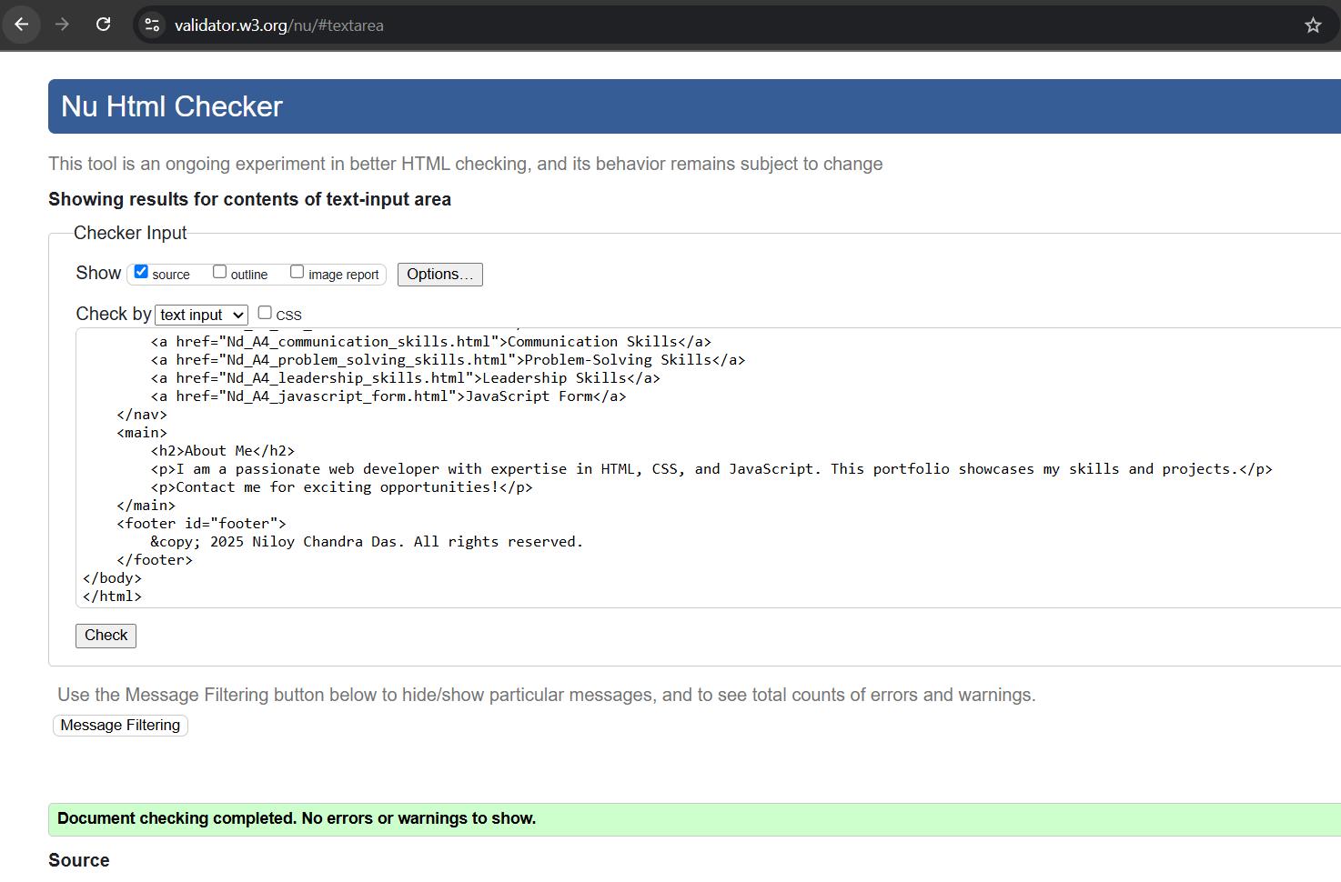

# Nd_A4_about.html

## Code

<!DOCTYPE html>

<html lang="en">

<head>

    <!-- Metadata and Links -->

    <meta charset="UTF-8"> <!-- Ensures proper encoding for special characters -->

    <meta name="viewport" content="width=device-width, initial-scale=1.0"> <!-- Makes the page responsive on all devices -->

    <link rel="stylesheet" href="CSS/portfolio.css"> <!-- Links to the external CSS file for styling -->

    <link rel="icon" href="Images/icon.png" type="image/x-icon"> <!-- Adds a small logo/icon to the browser tab -->

    <title>About Me</title> <!-- Sets the title of the webpage -->

</head>

<body>

    <!-- Header Section -->

    <header>

        <div class="logo-container">

            <img src="Images/logo.png" alt="Company Logo" width="100"> <!-- Displays the company logo -->

        </div>

        <h1>About Us</h1> <!-- Main heading of the page -->

    </header>

    <!-- Navigation Bar -->

    <nav>

        <a href="index.html">Home</a>

        <a href="Nd_A4_resume.html">Resume</a>

        <a href="Nd_A4_about.html">About</a>

        <a href="Nd_A4_web_skills.html">Web Skills</a>

        <a href="Nd_A4_communication_skills.html">Communication Skills</a>

        <a href="Nd_A4_problem_solving_skills.html">Problem-Solving Skills</a>

        <a href="Nd_A4_leadership_skills.html">Leadership Skills</a>

        <a href="Nd_A4_javascript_form.html">JavaScript Form</a>

    </nav>

    <!-- Main Content -->

    <main>

        <h2>Who Am I?</h2> <!-- Subheading for personal introduction -->

        <p>I am a passionate traveler and web developer with a love for creating digital experiences.</p> <!-- Short description about yourself -->

        <h2>Company Mission</h2> <!-- Subheading for the company mission -->

        <p>To provide exceptional travel services that inspire exploration and cultural exchange.</p> <!-- Description of the company's mission -->

        <p>&copy; Copyright Symbol: &copy;</p> <!-- Example of how to use the copyright symbol -->

    </main>

    <!-- Footer -->

    <footer id="footer">

        &copy; 2025 Niloy Chandra Das. All rights reserved. Permission granted to use all content on this site.<br> <!-- Copyright notice -->

        Contact: <a href="mailto:shivunathdas08@gmail.com">shivunathdas08@gmail.com</a> | Phone: <a href="tel:0435583588">0435583588</a> <!-- Contact information in the footer -->

    </footer>

</body>

</html>

## Validation

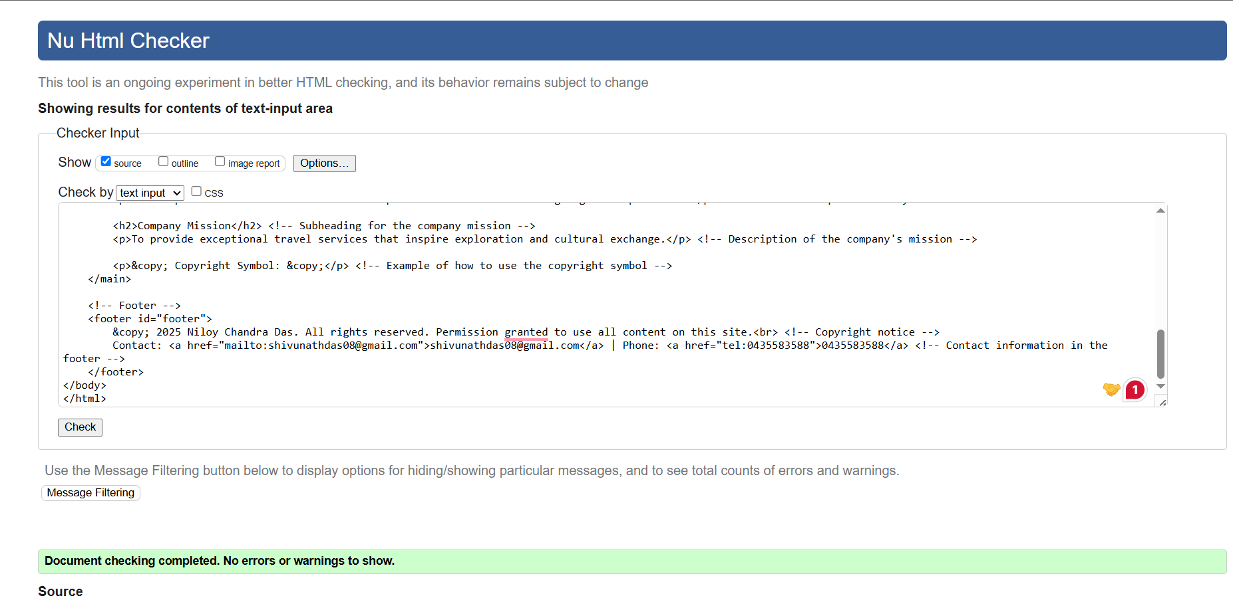

# Nd_A4_communication_skills.html

## Code

<!DOCTYPE html>

<html lang="en">

<head>

<!-- Metadata and Links -->

<meta charset="UTF-8"> <!-- Ensures proper encoding for special characters -->

<meta name="viewport" content="width=device-width, initial-scale=1.0"> <!-- Makes the page responsive on all devices -->

<link rel="stylesheet" href="CSS/portfolio.css"> <!-- Links to the external CSS file for styling -->

<title>Communication Skills</title> <!-- Sets the title of the webpage -->

</head>

<body>

<!-- Header Section -->

<header>

<div class="logo-container">

<img src="Images/logo.png" alt="Company Logo" width="100"> <!-- Displays the company logo -->

</div>

<h1>Communication Skills</h1> <!-- Main heading of the page -->

</header>

<!-- Navigation Bar -->

<nav>

<a href="index.html">Home</a> <!-- Link to the Home page -->

<a href="Nd_A4_resume.html">Resume</a> <!-- Link to the Resume page -->

<a href="Nd_A4_about.html">About</a> <!-- Link to the About page -->

<a href="Nd_A4_web_skills.html">Web Skills</a> <!-- Link to the Web Skills page -->

<a href="Nd_A4_communication_skills.html">Communication Skills</a> <!-- Link to the Communication Skills page -->

<a href="Nd_A4_problem_solving_skills.html">Problem-Solving Skills</a> <!-- Link to the Problem-Solving Skills page -->

<a href="Nd_A4_leadership_skills.html">Leadership Skills</a> <!-- Link to the Leadership Skills page -->

<a href="Nd_A4_javascript_form.html">JavaScript Form</a> <!-- Link to the JavaScript Form page -->

</nav>

<!-- Main Content -->

<main>

<!-- Verbal Communication Section -->

<section>

<h2>Verbal Communication</h2> <!-- Subheading for verbal communication -->

<p>

In my role as a houseman at Meriton Suites, I communicated effectively with over 150 diverse clients daily,

addressing their needs and ensuring a seamless travel experience.

</p> <!-- Example of verbal communication in a tourism context -->

</section>

<!-- Email and Phone Communication Section -->

<section>

<h2>Email and Phone Communication</h2> <!-- Subheading for email and phone communication -->

<p>

I handled client inquiries via email and phone, resolving issues efficiently and maintaining professionalism.

This ensured smooth communication between guests and the hotel management.

</p> <!-- Example of written and verbal communication in customer service -->

</section>

<!-- Promoting Tourism Packages Section -->

<section>

<h2>Promoting Tourism Packages</h2> <!-- Subheading for promoting tourism packages -->

<p>

As CEO of Niloy & Asif, I created marketing strategies to promote floral products, which can be adapted to

promoting travel packages and destinations in the tourism industry.

</p> <!-- Example of communication skills applied to marketing -->

</section>

</main>

<!-- Footer -->

<footer id="footer">

&copy; 2025 Niloy Chandra Das. All rights reserved. <!-- Copyright notice -->

</footer>

</body>

</html>

## Validation

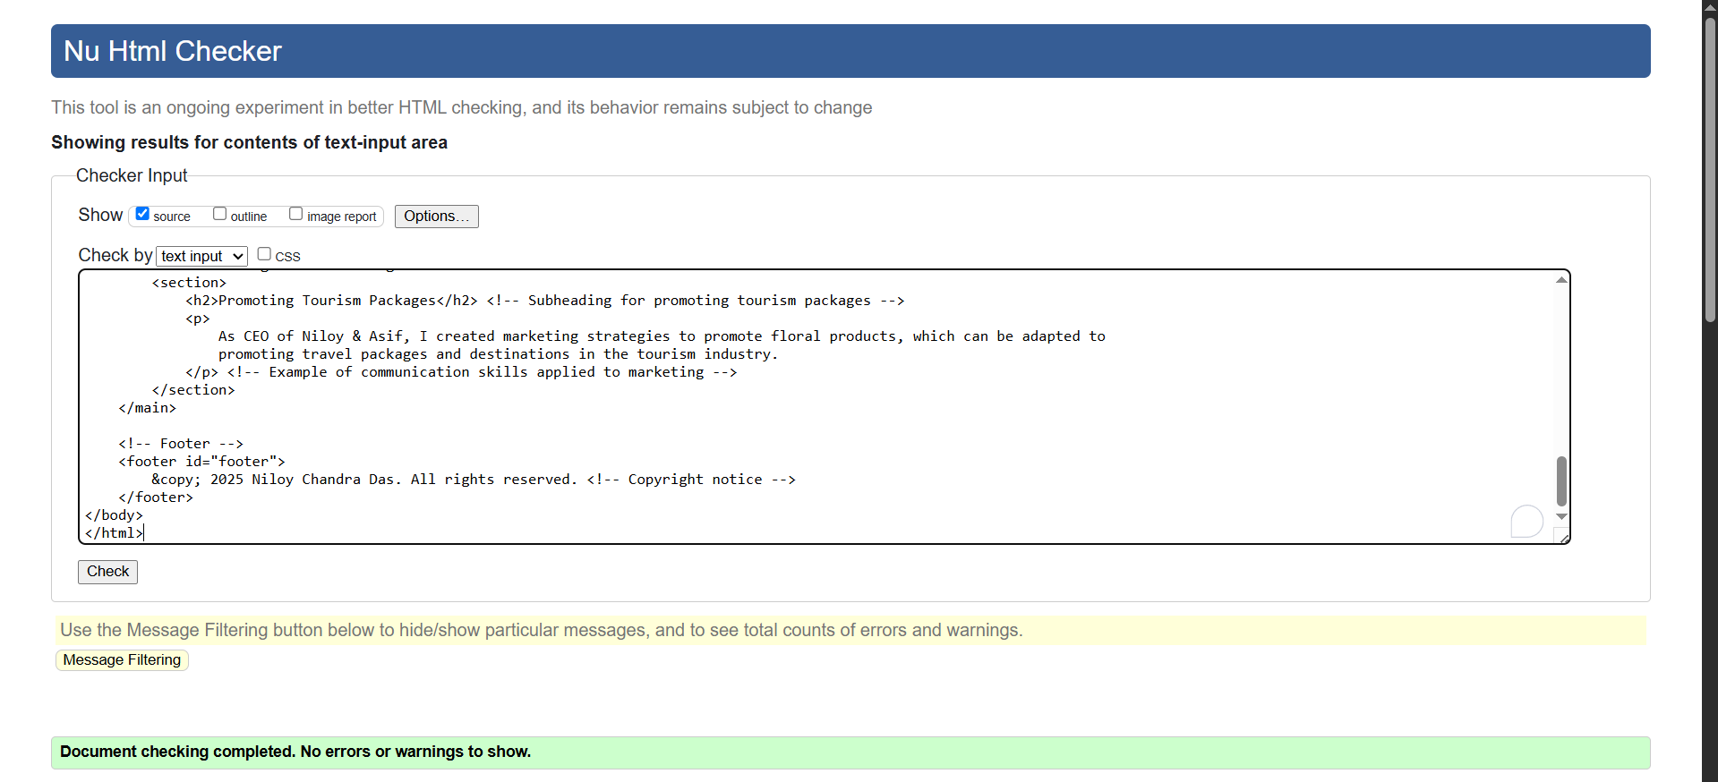

# Nd_A4_leadership_skills.html

## Code

<!DOCTYPE html>

<html lang="en">

<head>

    <!-- Metadata and Links -->

    <meta charset="UTF-8"> <!-- Ensures proper encoding for special characters -->

    <meta name="viewport" content="width=device-width, initial-scale=1.0"> <!-- Makes the page responsive on all devices -->

    <link rel="stylesheet" href="CSS/portfolio.css"> <!-- Links to the external CSS file for styling -->

    <title>Leadership Skills</title> <!-- Sets the title of the webpage -->

</head>

<body>

    <!-- Header Section -->

    <header>

        <div class="logo-container">

            <img src="Images/logo.png" alt="Company Logo" width="100"> <!-- Displays the company logo -->

        </div>

        <h1>Leadership Skills</h1> <!-- Main heading of the page -->

    </header>

    <!-- Navigation Bar -->

    <nav>

        <a href="index.html">Home</a> <!-- Link to the Home page -->

        <a href="Nd_A4_resume.html">Resume</a> <!-- Link to the Resume page -->

        <a href="Nd_A4_about.html">About</a> <!-- Link to the About page -->

        <a href="Nd_A4_web_skills.html">Web Skills</a> <!-- Link to the Web Skills page -->

        <a href="Nd_A4_communication_skills.html">Communication Skills</a> <!-- Link to the Communication Skills page -->

        <a href="Nd_A4_problem_solving_skills.html">Problem-Solving Skills</a> <!-- Link to the Problem-Solving Skills page -->

        <a href="Nd_A4_leadership_skills.html">Leadership Skills</a> <!-- Link to the Leadership Skills page -->

        <a href="Nd_A4_javascript_form.html">JavaScript Form</a> <!-- Link to the JavaScript Form page -->

    </nav>

    <!-- Main Content -->

    <main>

        <!-- Team Management Section -->

        <section>

            <h2>Team Management</h2> <!-- Subheading for team management -->

            <p>

                As a tutor, I led a team of 5 tutors at Oddhayon Academy, ensuring collaboration and meeting deadlines effectively—skills transferable to managing tourism teams.

            </p> <!-- Example of leadership in team management -->

        </section>

        <!-- Event Organization Section -->

        <section>

            <h2>Event Organization</h2> <!-- Subheading for event organization -->

            <p>

                As a member of the Leo Club, I organized community events attended by over 200 participants, showcasing strong organizational skills vital for tourism events.

            </p> <!-- Example of leadership in organizing events -->

        </section>

        <!-- Growth Strategies Section -->

        <section>

            <h2>Growth Strategies</h2> <!-- Subheading for growth strategies -->

            <p>

                As CEO of Niloy & Asif, I developed growth strategies that increased revenue by 20% annually. These skills can drive business growth in the tourism sector.

            </p> <!-- Example of leadership in driving business growth -->

        </section>

    </main>

    <!-- Footer -->

    <footer id="footer">

        &copy; 2025 Niloy Chandra Das. All rights reserved. <!-- Copyright notice -->

    </footer>

</body>

</html>

## Validation

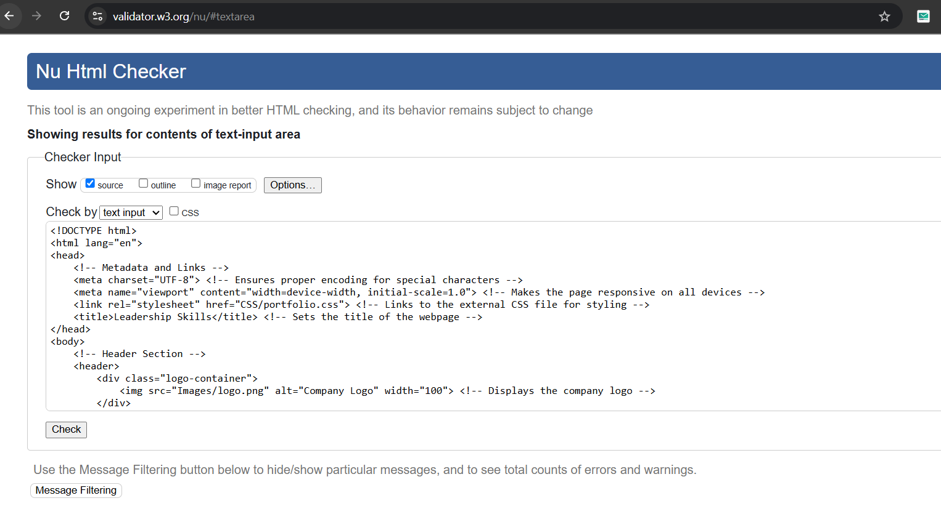

# Nd_A4_problem_solving_skills.html

## Code

<!DOCTYPE html>

<html lang="en">

<head>

<!-- Metadata and Links -->

<meta charset="UTF-8"> <!-- Ensures proper encoding for special characters -->

<meta name="viewport" content="width=device-width, initial-scale=1.0"> <!-- Makes the page responsive on all devices -->

<link rel="stylesheet" href="CSS/portfolio.css"> <!-- Links to the external CSS file for styling -->

<title>Problem-Solving Skills</title> <!-- Sets the title of the webpage -->

</head>

<body>

<!-- Header Section -->

<header>

<div class="logo-container">

<img src="Images/logo.png" alt="Company Logo" width="100"> <!-- Displays the company logo -->

</div>

<h1>Problem-Solving Skills</h1> <!-- Main heading of the page -->

</header>

<!-- Navigation Bar -->

<nav>

<a href="index.html">Home</a> <!-- Link to the Home page -->

<a href="Nd_A4_resume.html">Resume</a> <!-- Link to the Resume page -->

<a href="Nd_A4_about.html">About</a> <!-- Link to the About page -->

<a href="Nd_A4_web_skills.html">Web Skills</a> <!-- Link to the Web Skills page -->

<a href="Nd_A4_communication_skills.html">Communication Skills</a> <!-- Link to the Communication Skills page -->

<a href="Nd_A4_problem_solving_skills.html">Problem-Solving Skills</a> <!-- Link to the Problem-Solving Skills page -->

<a href="Nd_A4_leadership_skills.html">Leadership Skills</a> <!-- Link to the Leadership Skills page -->

<a href="Nd_A4_javascript_form.html">JavaScript Form</a> <!-- Link to the JavaScript Form page -->

</nav>

<!-- Main Content -->

<main>

<!-- Streamlining Operations Section -->

<section>

<h2>Streamlining Operations</h2> <!-- Subheading for streamlining operations -->

<p>

At Meriton Suites, I streamlined daily operations to handle up to 300 client requests per day,

ensuring efficiency and enhancing the guest experience.

</p> <!-- Example of problem-solving in improving operational efficiency -->

</section>

<!-- Resolving Client Concerns Section -->

<section>

<h2>Resolving Client Concerns</h2> <!-- Subheading for resolving client concerns -->

<p>

I resolved conflicts and addressed concerns among diverse clients, ensuring their satisfaction

and loyalty—a critical aspect of the tourism industry.

</p> <!-- Example of problem-solving in customer service -->

</section>

<!-- Negotiating Partnerships Section -->

<section>

<h2>Negotiating Partnerships</h2> <!-- Subheading for negotiating partnerships -->

<p>

As CEO of Niloy & Asif, I negotiated prices with suppliers to reduce costs by 15%.

This skill can help secure partnerships with airlines, hotels, and tour operators in tourism.

</p> <!-- Example of problem-solving in cost management and negotiation -->

</section>

</main>

<!-- Footer -->

<footer id="footer">

&copy; 2025 Niloy Chandra Das. All rights reserved. <!-- Copyright notice -->

</footer>

</body>

</html>

## Validation

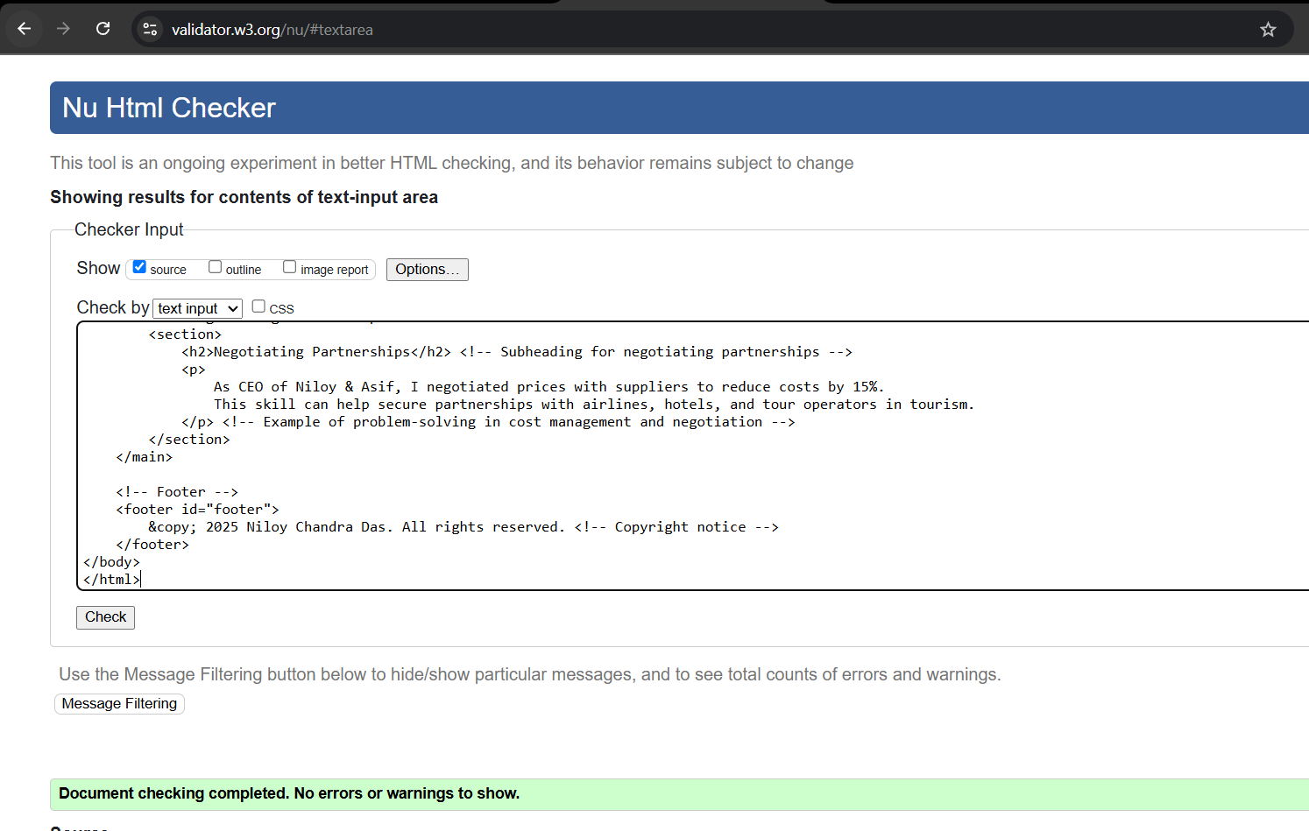

# Nd_A4_web_skills.html

## Code

<!DOCTYPE html>

<html lang="en">

<head>

    <!-- Metadata and Links -->

    <meta charset="UTF-8"> <!-- Ensures proper encoding for special characters -->

    <meta name="viewport" content="width=device-width, initial-scale=1.0"> <!-- Makes the page responsive on all devices -->

    <link rel="stylesheet" href="CSS/portfolio.css"> <!-- Links to the external CSS file for styling -->

    <title>Web Development Skills</title> <!-- Sets the title of the webpage -->

    <style>

        /* Styles for live code examples */

        .code-output {

            margin: 20px 0; /* Adds vertical spacing around the code output section */

            padding: 15px; /* Adds internal spacing for better readability */

            border: 1px solid #ccc; /* Adds a border around the code output */

            border-radius: 5px; /* Rounds the corners of the border */

            background-color: #f9f9f9; /* Light gray background for contrast */

        }

        .code-output h3 {

            margin-top: 0; /* Removes top margin for cleaner spacing */

        }

    </style>

</head>

<body>

    <!-- Header Section -->

    <header>

        <div class="logo-container">

            <img src="Images/logo.png" alt="Company Logo" width="100"> <!-- Displays the company logo -->

        </div>

        <h1>Web Development Skills</h1> <!-- Main heading of the page -->

    </header>

    <!-- Navigation Bar -->

    <nav>

        <a href="index.html">Home</a> <!-- Link to the Home page -->

        <a href="Nd_A4_resume.html">Resume</a> <!-- Link to the Resume page -->

        <a href="Nd_A4_about.html">About</a> <!-- Link to the About page -->

        <a href="Nd_A4_web_skills.html">Web Skills</a> <!-- Link to the Web Skills page -->

        <a href="Nd_A4_communication_skills.html">Communication Skills</a> <!-- Link to the Communication Skills page -->

        <a href="Nd_A4_problem_solving_skills.html">Problem-Solving Skills</a> <!-- Link to the Problem-Solving Skills page -->

        <a href="Nd_A4_leadership_skills.html">Leadership Skills</a> <!-- Link to the Leadership Skills page -->

        <a href="Nd_A4_javascript_form.html">JavaScript Form</a> <!-- Link to the JavaScript Form page -->

    </nav>

    <!-- Main Content -->

    <main>

        <!-- HTML Section -->

        <section>

            <h2>HTML</h2> <!-- Subheading for the HTML section -->

            <p>I have expertise in structuring web pages using semantic HTML5 elements. Below is an example of a responsive navigation bar:</p>

            <div class="code-output">

                <h3>Output:</h3> <!-- Subheading for the live code example -->

                <nav style="background-color: #00ced1; padding: 10px; border-radius: 5px;">

                    <a href="#" style="color: white; margin: 0 10px; text-decoration: none;">Home</a>

                    <a href="#" style="color: white; margin: 0 10px; text-decoration: none;">About</a>

                    <a href="#" style="color: white; margin: 0 10px; text-decoration: none;">Contact</a>

                </nav>

            </div>

            <p><strong>Expertise:</strong> Proficient in creating semantic, accessible, and SEO-friendly HTML structures. Experienced in building responsive layouts for various devices.</p>

        </section>

        <!-- CSS Section -->

        <section>

            <h2>CSS</h2> <!-- Subheading for the CSS section -->

            <p>I use CSS3 to style websites and ensure responsiveness across devices. Here's an example of a gradient background:</p>

            <div class="code-output">

                <h3>Output:</h3> <!-- Subheading for the live code example -->

                <div style="width: 100%; height: 100px; background: linear-gradient(135deg, #f5f7fa, #c3cfe2); border: 1px solid #ccc; border-radius: 5px;"></div>

            </div>

            <p><strong>Expertise:</strong> Skilled in modern CSS techniques such as Flexbox, Grid, animations, and gradients. Capable of designing visually appealing and responsive interfaces.</p>

        </section>

        <!-- JavaScript Section -->

        <section>

            <h2>JavaScript</h2> <!-- Subheading for the JavaScript section -->

            <p>I implement interactive features using JavaScript. Below is an example of form validation:</p>

            <div class="code-output">

                <h3>Output:</h3> <!-- Subheading for the live code example -->

                <form name="signup" onsubmit="return validateForm()" style="display: flex; flex-direction: column; gap: 10px;">

                    <label for="name">Name:</label>

                    <input type="text" id="name" name="name" placeholder="Enter your name">

                    <button type="submit">Submit</button>

                </form>

                <script>

                    // Function to validate the form input

                    function validateForm() {

                        const name = document.forms["signup"]["name"].value; // Retrieves the value of the "Name" field

                        if (name === "") { // Checks if the field is empty

                            alert("Name is required."); // Displays an error message

                            return false; // Prevents form submission

                        }

                        return true; // Allows form submission if validation passes

                    }

                </script>

            </div>

            <p><strong>Expertise:</strong> Experienced in implementing dynamic and interactive features, including form validation, DOM manipulation, and event handling. Strong understanding of vanilla JavaScript and frameworks like React.</p>

        </section>

 <!-- React Section -->

<section>

    <h2>React</h2> <!-- Subheading for the React section -->

    <p>I build dynamic user interfaces using React. Here's an example of a functional component:</p>

    <div class="code-output">

        <h3>Output:</h3> <!-- Subheading for the live code example -->

        <div style="padding: 15px; background-color: #e0f7fa; border-radius: 5px;">

            <!-- Changed <h1> to plain text -->

            Hello, World!

        </div>

    </div>

    <p><strong>Expertise:</strong> Proficient in building reusable components and managing state in React. Experienced in creating single-page applications (SPAs) with efficient data flow and routing.</p>

</section>

    </main>

    <!-- Footer -->

    <footer id="footer">

        &copy; 2025 Niloy Chandra Das. All rights reserved. <!-- Copyright notice -->

    </footer>

</body>

</html>

## Validation

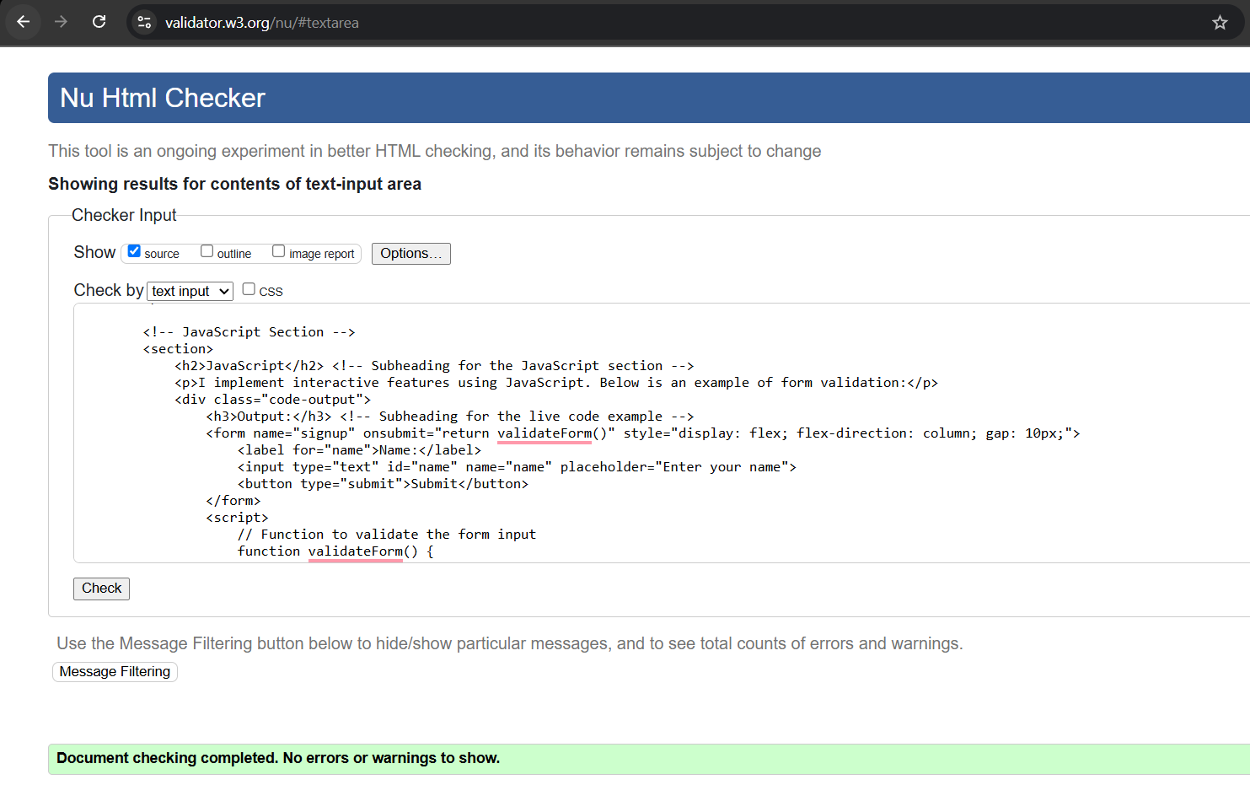

# Nd_A4_resume.html

## Code

<!DOCTYPE html>

<html lang="en">

<head>

    <!-- Metadata and Links -->

    <meta charset="UTF-8"> <!-- Ensures proper encoding for special characters -->

    <meta name="viewport" content="width=device-width, initial-scale=1.0"> <!-- Makes the page responsive on all devices -->

    <link rel="stylesheet" href="CSS/portfolio.css"> <!-- Links to the external CSS file for styling -->

    <link rel="icon" href="Images/icon.png" type="image/x-icon"> <!-- Adds a small logo/icon to the browser tab -->

    <title>Portfolio - Resume</title> <!-- Sets the title of the webpage -->

</head>

<body>

    <!-- Header Section -->

    <header>

        <div class="logo-container">

            <img src="Images/logo.png" alt="Company Logo" width="100"> <!-- Displays the company logo -->

        </div>

        <h1>My Resume</h1> <!-- Main heading of the page -->

    </header>

    <!-- Navigation Bar -->

    <nav>

        <a href="index.html">Home</a>

        <a href="Nd_A4_resume.html">Resume</a>

        <a href="Nd_A4_about.html">About</a>

        <a href="Nd_A4_web_skills.html">Web Skills</a>

        <a href="Nd_A4_communication_skills.html">Communication Skills</a>

        <a href="Nd_A4_problem_solving_skills.html">Problem-Solving Skills</a>

        <a href="Nd_A4_leadership_skills.html">Leadership Skills</a>

        <a href="Nd_A4_javascript_form.html">JavaScript Form</a>

    </nav>

    <!-- Main Content -->

    <main>

        <!-- Profile Section -->

        <section style="margin-bottom: 40px;">

            <h2>Profile</h2> <!-- Subheading for the profile section -->

            <div style="display: flex; align-items: center; margin-bottom: 20px;">

                <img src="Images/profile.jpeg" alt="Profile Picture" width="150" style="border-radius: 10px; margin-right: 20px;"> <!-- Profile picture -->

                <div>

                    <p><strong>Niloy Chandra Das</strong></p> <!-- Name -->

                    <p>Address: Unit 1, 38 Railway Parade, Glenfield NSW 2167</p> <!-- Address -->

                    <p>Phone: <a href="tel:0435583588">0435583588</a></p> <!-- Phone number -->

                    <p>Email: <a href="mailto:shivunathdas08@gmail.com">shivunathdas08@gmail.com</a></p> <!-- Email address -->

                </div>

            </div>

            <p>

                Driven by a proactive approach, I harness resourcefulness and goal-oriented thinking to thrive in multitasking scenarios.

                My adaptability across diverse situations, coupled with a strong commitment, positions me to effectively bridge the gap

                between students and the university management. With a solid foundation in teamwork and conflict resolution, I am dedicated

                to facilitating open communication, organizing events, and providing support and guidance to my peers.

            </p> <!-- Personal description -->

        </section>

        <!-- Experience Section -->

        <section style="margin-bottom: 40px;">

            <h2>Experience</h2> <!-- Subheading for the experience section -->

            <article style="margin-bottom: 20px;">

                <h3>Houseman (Part-time)</h3> <!-- Job title -->

                <p><strong>Meriton Suites Waterloo</strong> | March 2024 - Ongoing</p> <!-- Company name and duration -->

                <ul>

                    <li>Promoted from Room Attendant to Houseman within 5 months.</li> <!-- Key achievement -->

                    <li>Responsive and flexible to meet the needs of more than 150 diverse clients per day.</li> <!-- Responsibility -->

                    <li>Streamlined daily operations among complex competing priorities, handling up to 300 requests per day.</li> <!-- Responsibility -->

                    <li>Ensured accurate detailing of quality checks and timely updates via multiple communication channels.</li> <!-- Responsibility -->

                    <li>Maintained strong compliance with ethical responsibilities in confidentiality, safety, and privacy concerns.</li> <!-- Responsibility -->

                    <li>Collaborated effectively with team members to enhance overall efficiency of the hotel’s productivity.</li> <!-- Responsibility -->

                </ul>

            </article>

            <article style="margin-bottom: 20px;">

                <h3>Maths and Biology Tutor (Part-time)</h3> <!-- Job title -->

                <p><strong>Oddhayon Academy, Dhaka, Bangladesh</strong> | December 2022 - December 2023</p> <!-- Company name and duration -->

                <ul>

                    <li>Autonomously prepared lesson plans and materials for classroom teaching.</li> <!-- Responsibility -->

                    <li>Provided instructional support and guidance to 5 classes of 50 students each.</li> <!-- Responsibility -->

                    <li>Graded assessments, monitored student progress, and offered feedback to supervising teachers and parents.</li> <!-- Responsibility -->

                    <li>Managed complex relationships with students, parents, colleagues, and managers with professional etiquette.</li> <!-- Responsibility -->

                </ul>

            </article>

            <article>

                <h3>CEO and Co-Founder (Part-time)</h3> <!-- Job title -->

                <p><strong>Niloy & Asif, Dhaka, Bangladesh</strong> | October 2021 - February 2024</p> <!-- Company name and duration -->

                <ul>

                    <li>Developed and implemented the company’s vision, goals, and growth strategy.</li> <!-- Responsibility -->

                    <li>Created marketing strategies to build the brand and drive sales growth.</li> <!-- Responsibility -->

                    <li>Ensured floral product quality through daily visits to local markets and negotiated prices for cost savings.</li> <!-- Responsibility -->

                    <li>Managed legal compliance and maintained strong relationships with stakeholders.</li> <!-- Responsibility -->

                </ul>

            </article>

        </section>

        <!-- Education & Qualifications Section -->

        <section style="margin-bottom: 40px;">

            <h2>Education & Qualifications</h2> <!-- Subheading for education -->

            <table class="skills-table">

                <thead>

                    <tr>

                        <th>Year</th> <!-- Column header -->

                        <th>Degree/Course</th> <!-- Column header -->

                        <th>Institution</th> <!-- Column header -->

                    </tr>

                </thead>

                <tbody>

                    <tr>

                        <td>2024</td> <!-- Year -->

                        <td>Bachelor of Information Technology</td> <!-- Degree/Course -->

                        <td>Charles Sturt University Sydney</td> <!-- Institution -->

                    </tr>

                    <tr>

                        <td>2022</td> <!-- Year -->

                        <td>Higher Secondary Certificate</td> <!-- Degree/Course -->

                        <td>Dhaka Imperial College</td> <!-- Institution -->

                    </tr>

                    <tr>

                        <td>2020</td> <!-- Year -->

                        <td>Secondary School Certificate</td> <!-- Degree/Course -->

                        <td>National Ideal School & College</td> <!-- Institution -->

                    </tr>

                </tbody>

            </table>

        </section>

        <!-- Future Studies Section -->

        <section style="margin-bottom: 40px;">

            <h2>Future Studies</h2> <!-- Subheading for future studies -->

            <p>Below are the units/subjects I plan to undertake as part of my academic journey:</p> <!-- Description -->

            <table class="skills-table">

                <thead>

                    <tr>

                        <th>Unit Code</th> <!-- Column header -->

                        <th>Unit Name</th> <!-- Column header -->

                        <th>Prerequisites/Notes</th> <!-- Column header -->

                    </tr>

                </thead>

                <tbody>

                    <tr>

                        <td>T60/2025</td> <!-- Unit code -->

                        <td>ITC206 Programming in Java 1</td> <!-- Unit name -->

                        <td>Assumed knowledge: ITC104 or ITC106</td> <!-- Prerequisites/Notes -->

                    </tr>

                    <tr>

                        <td>T60/2025</td> <!-- Unit code -->

                        <td>ITC218 ICT Project Management</td> <!-- Unit name -->

                        <td>No prerequisites mentioned</td> <!-- Prerequisites/Notes -->

                    </tr>

                    <tr>

                        <td>T60/2025</td> <!-- Unit code -->

                        <td>ITC358 Cyber Security</td> <!-- Unit name -->

                        <td>Assumed knowledge: ITC161, ITC106, and ITC292</td> <!-- Prerequisites/Notes -->

                    </tr>

                    <tr>

                        <td>T60/2025</td> <!-- Unit code -->

                        <td>ITC205* Professional Programming Practice</td> <!-- Unit name -->

                        <td>Subject to be confirmed</td> <!-- Prerequisites/Notes -->

                    </tr>

                </tbody>

            </table>

        </section>

        <!-- Skills Section -->

        <section style="margin-bottom: 40px;">

            <h2>Skills</h2> <!-- Subheading for skills -->

            <h3>Language Proficiency</h3> <!-- Subheading for language skills -->

            <ul>

                <li>English, Bangla, Hindi</li> <!-- Languages spoken -->

                <li>Achieved overall score: 6.5 in IELTS</li> <!-- Language test score -->

            </ul>

            <h3>Interpersonal Skills</h3> <!-- Subheading for interpersonal skills -->

            <ul>

                <li>Self-motivation</li> <!-- Skill -->

                <li>Flexibility</li> <!-- Skill -->

                <li>Communication (Verbal, Emails, and Phone Calls)</li> <!-- Skill -->

                <li>Professional Ethics</li> <!-- Skill -->

                <li>Problem-solving</li> <!-- Skill -->

                <li>Teamwork</li> <!-- Skill -->

                <li>Conflict Resolution</li> <!-- Skill -->

            </ul>

            <h3>Soft Skills</h3> <!-- Subheading for soft skills -->

            <ul>

                <li>Proficient in MS Office</li> <!-- Skill -->

            </ul>

        </section>

        <!-- Additional Information Section -->

        <section>

            <h2>Additional Information</h2> <!-- Subheading for additional information -->

            <ul>

                <li>Member of Leo Club of Dhaka Imperial, participated in various events organized by Leo District 315 A2 Bangladesh, Lions Clubs International.</li> <!-- Extracurricular activity -->

                <li>Rover Scout Member of Herald Open Scout Group, Bangladesh Scouts.</li> <!-- Extracurricular activity -->

            </ul>

        </section>

    </main>

    <!-- Footer -->

    <footer id="footer">

        &copy; 2025 Niloy Chandra Das. All rights reserved. Permission granted to use all content on this site.<br> <!-- Copyright notice -->

        Contact: <a href="mailto:shivunathdas08@gmail.com">shivunathdas08@gmail.com</a> | Phone: <a href="tel:0435583588">0435583588</a> <!-- Contact information -->

    </footer>

</body>

</html>

## Validation

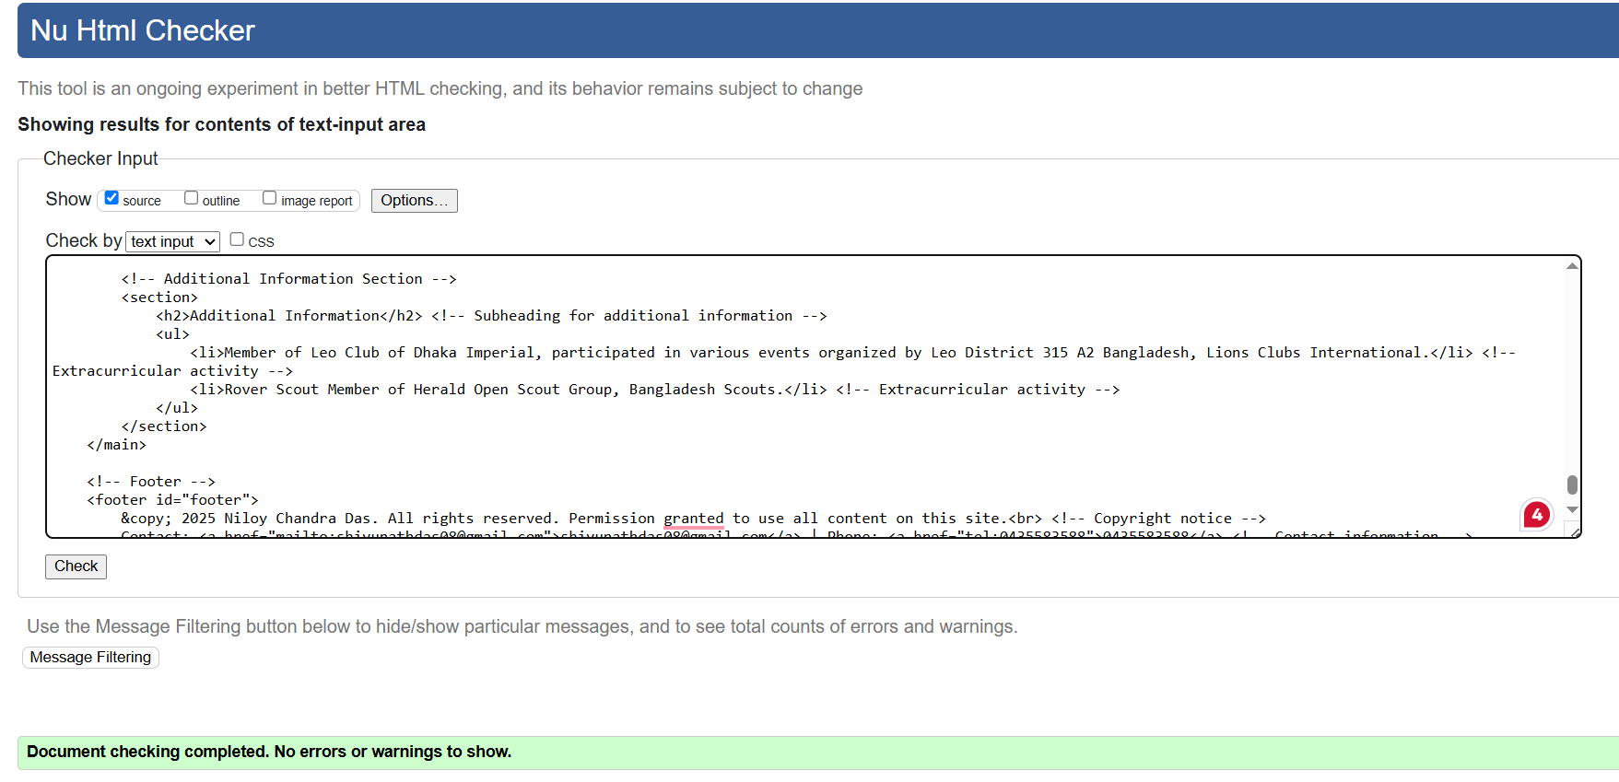

# Nd_A4_javascript_form.html

## Code

<!DOCTYPE html>

<html lang="en">

<head>

<!-- Metadata and Links -->

<meta charset="UTF-8"> <!-- Ensures proper encoding for special characters -->

<meta name="viewport" content="width=device-width, initial-scale=1.0"> <!-- Makes the page responsive on all devices -->

<link rel="stylesheet" href="CSS/portfolio.css"> <!-- Links to the external CSS file for styling -->

<title>JavaScript Page</title> <!-- Sets the title of the webpage -->

<script>

// JavaScript function to open the form in a new tab

function openForm() {

window.open("form.html", "_blank"); // Opens the newsletter signup form in a new browser tab

}

</script>

</head>

<body>

<!-- Header Section -->

<header>

<div class="logo-container">

<img src="Images/logo.png" alt="Company Logo" width="100"> <!-- Displays the company logo -->

</div>

<h1>JavaScript Form</h1> <!-- Main heading of the page -->

</header>

<!-- Navigation Bar -->

<nav>

<a href="index.html">Home</a> <!-- Link to the Home page -->

<a href="Nd_A4_resume.html">Resume</a> <!-- Link to the Resume page -->

<a href="Nd_A4_about.html">About</a> <!-- Link to the About page -->

<a href="Nd_A4_web_skills.html">Web Skills</a> <!-- Link to the Web Skills page -->

<a href="Nd_A4_communication_skills.html">Communication Skills</a> <!-- Link to the Communication Skills page -->

<a href="Nd_A4_problem_solving_skills.html">Problem-Solving Skills</a> <!-- Link to the Problem-Solving Skills page -->

<a href="Nd_A4_leadership_skills.html">Leadership Skills</a> <!-- Link to the Leadership Skills page -->

<a href="Nd_A4_javascript_form.html">JavaScript Form</a> <!-- Link to the JavaScript Form page -->

</nav>

<!-- Main Content -->

<main>

<h2>Open Newsletter Signup Form</h2> <!-- Subheading for the form section -->

<button class="open-form-btn" onclick="openForm()">Open Form</button> <!-- Button to open the newsletter signup form -->

</main>

<!-- Footer -->

<footer id="footer">

&copy; 2025 Niloy Chandra Das. All rights reserved. <!-- Copyright notice -->

</footer>

</body>

</html>

## Validation

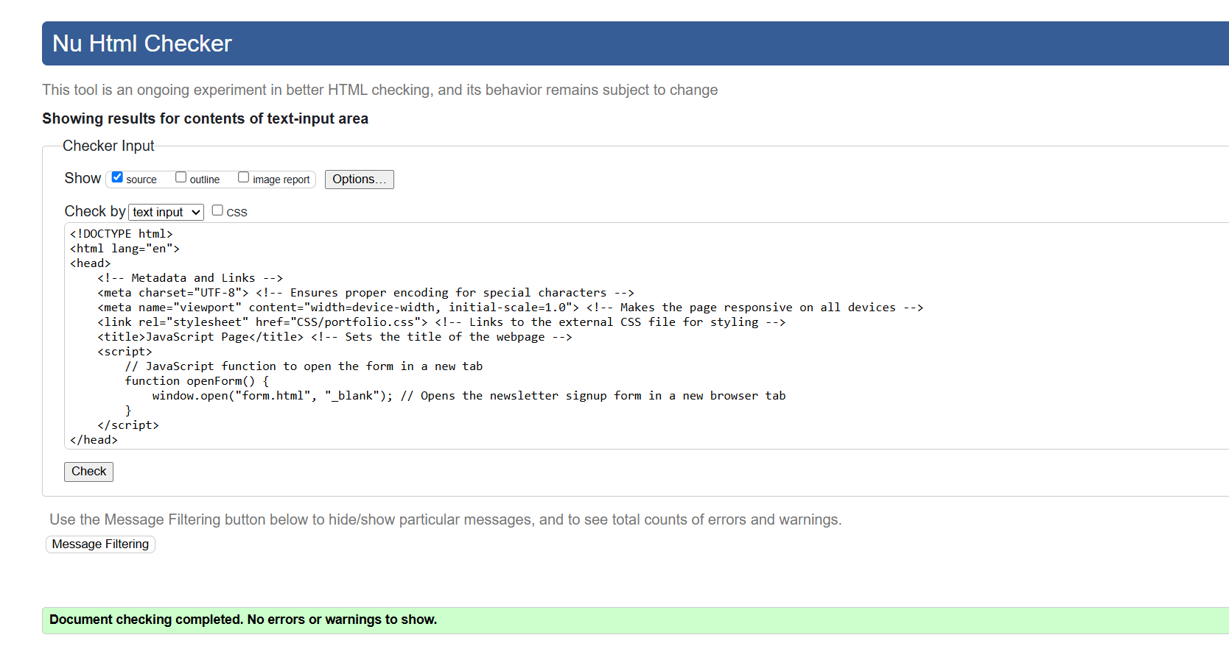

# form.html

## Code

<!DOCTYPE html>

<html lang="en">

<head>

<!-- Metadata and Links -->

<meta charset="UTF-8"> <!-- Ensures proper encoding for special characters -->

<meta name="viewport" content="width=device-width, initial-scale=1.0"> <!-- Makes the page responsive on all devices -->

<link rel="stylesheet" href="CSS/form.css"> <!-- Links to the external CSS file for styling -->

<title>Newsletter Signup</title> <!-- Sets the title of the webpage -->

<script>

// JavaScript function to display a welcome message when the page loads

window.onload = function() {

alert("Welcome to the Tourism Corporation Newsletter Signup");

};

// JavaScript function to validate the form before submission

function validateForm() {

const firstName = document.forms["signup"]["firstName"].value; // Retrieves the value of the "First Name" field

const lastName = document.forms["signup"]["lastName"].value; // Retrieves the value of the "Last Name" field

// Checks if the "First Name" or "Last Name" fields are empty

if (firstName === "" || lastName === "") {

alert("First Name and Last Name are required."); // Displays an error message

return false; // Prevents form submission

}

return true; // Allows form submission if validation passes

}

</script>

</head>

<body>

<!-- Main Heading -->

<h1>Tourism Corporation Newsletter Signup</h1> <!-- Title of the form -->

<!-- Form Section -->

<form name="signup" action="http://csusap.csu.edu.au/cgi-bin/echo_form" method="post" onsubmit="return validateForm()">

<!-- First Name Field -->

<label for="firstName">First Name:</label><br>

<input type="text" id="firstName" name="firstName" maxlength="60" required><br><br> <!-- Input field for the user's first name -->

<!-- Last Name Field -->

<label for="lastName">Last Name:</label><br>

<input type="text" id="lastName" name="lastName" maxlength="60" required><br><br> <!-- Input field for the user's last name -->

<!-- Email Address Field -->

<label for="email">Email Address:</label><br>

<input type="email" id="email" name="email" maxlength="60" required><br><br> <!-- Input field for the user's email address -->

<!-- Age Range Selection -->

<label>Age Range:</label><br>

<input type="radio" id="age1" name="age" value="15-25" required> <!-- Radio button for age range 15-25 -->

<label for="age1">15-25</label>

<input type="radio" id="age2" name="age" value="26-35"> <!-- Radio button for age range 26-35 -->

<label for="age2">26-35</label>

<input type="radio" id="age3" name="age" value="36-45"> <!-- Radio button for age range 36-45 -->

<label for="age3">36-45</label>

<input type="radio" id="age4" name="age" value="46-55"> <!-- Radio button for age range 46-55 -->

<label for="age4">46-55</label>

<input type="radio" id="age5" name="age" value="55+"> <!-- Radio button for age range 55+ -->

<label for="age5">55+</label><br><br>

<!-- Services Selection -->

<label>Services:</label><br>

<input type="checkbox" id="service1" name="services" value="Adventure Tours"> <!-- Checkbox for Adventure Tours -->

<label for="service1">Adventure Tours</label>

<input type="checkbox" id="service2" name="services" value="Cultural Experiences"> <!-- Checkbox for Cultural Experiences -->

<label for="service2">Cultural Experiences</label>

<input type="checkbox" id="service3" name="services" value="Luxury Getaways"> <!-- Checkbox for Luxury Getaways -->

<label for="service3">Luxury Getaways</label>

<input type="checkbox" id="service4" name="services" value="Customized Itineraries"> <!-- Checkbox for Customized Itineraries -->

<label for="service4">Customized Itineraries</label>

<input type="checkbox" id="service5" name="services" value="Travel Insurance"> <!-- Checkbox for Travel Insurance -->

<label for="service5">Travel Insurance</label><br><br>

<!-- Comments Section -->

<label for="comments">Comments:</label><br>

<textarea id="comments" name="comments" cols="60" rows="3"></textarea><br><br> <!-- Text area for additional comments -->

<!-- Submit and Reset Buttons -->

<input type="submit" value="Submit"> <!-- Button to submit the form -->

<input type="reset" value="Reset"> <!-- Button to reset the form -->

</form>

</body>

</html>

## Validation

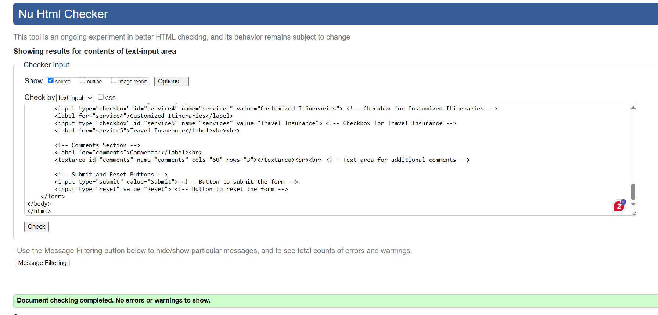

# portfolio.css

## Code

/* General Styles */

body {

    font-family: 'Arial', sans-serif; /* Use Arial font for the entire website */

    background: linear-gradient(135deg, #f5f7fa, #c3cfe2); /* Light gradient background */

    color: #333; /* Dark gray text color for readability */

    margin: 0; /* Remove default margins around the page */

    padding: 0; /* Remove default padding */

    display: flex; /* Use flexbox layout */

    flex-direction: column; /* Stack content vertically */

    min-height: 100vh; /* Ensure the page takes up the full screen height */

}

header {

    background: linear-gradient(135deg, #4b0082, #00ced1); /* Indigo to teal gradient for the header */

    color: white; /* White text for contrast */

    padding: 20px; /* Add spacing inside the header */

    text-align: center; /* Center align all text in the header */

}

h1 {

    color: #00ced1; /* Teal color for headings */

    text-align: center; /* Center align the heading */

    font-size: 2rem; /* Large font size for the main title */

    margin: 10px; /* Add some spacing around the heading */

}

p {

    font-size: 16px; /* Standard text size */

    line-height: 1.5; /* Add space between lines for better readability */

}

/* Center the logo */

.logo-container {

    display: flex; /* Use flexbox to align items */

    justify-content: center; /* Center horizontally */

    align-items: center; /* Center vertically */

    margin-top: 10px; /* Add some space above the logo */

}

.logo-container img {

    max-width: 100%; /* Make sure the logo doesn’t overflow its container */

    height: auto; /* Keep the image proportions correct */

}

/* Navigation Bar */

nav {

    background: linear-gradient(135deg, #4b0082, #00ced1); /* Gradient background for the navigation bar */

    padding: 40px 20px; /* Add spacing inside the navigation bar */

    text-align: center; /* Center align the links */

    box-shadow: 0 4px 6px rgba(0, 0, 0, 0.1); /* Add a subtle shadow for depth */

}

nav a {

    color: white; /* White text for links */

    text-decoration: none; /* Remove underline from links */

    margin: 0 10px; /* Add space between links */

    padding: 10px 20px; /* Add spacing inside each button */

    border-radius: 20px; /* Rounded corners for buttons */

    background: linear-gradient(45deg, #3550ca, #01fbff); /* Gradient background for buttons */

    font-family: 'Arial', sans-serif; /* Use Arial font */

    font-weight: bold; /* Bold text for links */

    transition: all 0.3s ease-in-out; /* Smooth animations for hover effects */

    box-shadow: 0 4px 6px rgba(0, 0, 0, 0.1); /* Add a subtle shadow to buttons */

}

nav a:hover {

    transform: scale(1.1); /* Slightly enlarge the button on hover */

    background: linear-gradient(135deg, #4b0082, #00ced1); /* Change gradient color on hover */

    box-shadow: 0 6px 10px #00ced1; /* Add a glowing effect on hover */

    text-shadow: 0 0 8px #4b0082; /* Add a glow effect to the text */

}

main {

    flex: 1; /* Push the footer to the bottom of the page */

    padding: 20px; /* Add spacing around the main content */

}

/* Footer Styles */

#footer {

    background: linear-gradient(135deg, #333, #444); /* Dark gradient background for the footer */

    color: white; /* White text for contrast */

    text-align: center; /* Center align the footer text */

    padding: 10px; /* Add spacing inside the footer */

    font-size: 14px; /* Smaller font size for the footer */

}

/* Ensure all links in the footer are white */

#footer a {

    color: white; /* White text for links */

    text-decoration: none; /* Remove underline */

    font-weight: bold; /* Bold text for links */

}

/* Hover effect for footer links */

#footer a:hover {

    text-decoration: underline; /* Add underline when hovering over links */

}

/* Table Styles */

.skills-table {

    width: 100%; /* Make the table take up the full width */

    border-collapse: collapse; /* Remove gaps between table borders */

    margin: 20px 0; /* Add space above and below the table */

    font-size: 16px; /* Standard text size for tables */

    text-align: left; /* Align text to the left */

}

.skills-table th,

.skills-table td {

    padding: 12px; /* Add spacing inside table cells */

    border: 1px solid #00ced1; /* Teal border for table cells */

}

.skills-table thead {

    background: linear-gradient(135deg, #4b0082, #00ced1); /* Gradient background for table headers */

    color: white; /* White text for headers */

}

.skills-table tbody tr:nth-child(even) {

    background-color: #f9f9f9; /* Light gray background for even rows */

}

.skills-table tbody tr:hover {

    background-color: #f1f1f1; /* Highlight row when hovered */

}

/* Highlight Class */

.highlight {

    color: #000000; /* Black text for highlighted items */

    font-weight: bold; /* Bold text for emphasis */

}

/* Unordered List Styling */

ul {

    list-style-type: square; /* Use square bullets for lists */

    list-style-position: inside; /* Keep markers inside the list */

}

/* Ordered List Styling */

ol {

    list-style-type: upper-roman; /* Use Roman numerals for ordered lists */

    list-style-position: inside; /* Keep markers inside the list */

}

/* Styling the markers (bullets or Roman numerals) */

ul li::marker,

ol li::marker {

    color: #00ced1; /* Teal color for list markers */

    font-size: 1em; /* Match marker size with text */

}

/* Keeping the text color black */

ul li,

ol li {

    color: black; /* Black text for list items */

}

/* Styling for the Open Form button */

.open-form-btn {

    background: linear-gradient(135deg, #4b0082, #00ced1); /* Gradient background */

    color: white; /* White text */

    font-size: 16px; /* Font size */

    font-weight: bold; /* Bold text */

    padding: 12px 24px; /* Padding for height and width */

    border: none; /* Remove default border */

    border-radius: 25px; /* Rounded corners */

    cursor: pointer; /* Pointer cursor on hover */

    transition: all 0.3s ease-in-out; /* Smooth transition for hover effects */

    box-shadow: 0 4px 6px rgba(0, 0, 0, 0.1); /* Subtle shadow for depth */

}

.open-form-btn:hover {

    transform: scale(1.1); /* Slightly enlarge the button on hover */

    background: linear-gradient(135deg, #00ced1, #4b0082); /* Reverse gradient on hover */

    box-shadow: 0 6px 10px #00ced1; /* Add a glowing effect on hover */

    text-shadow: 0 0 8px #4b0082; /* Add a glow effect to the text */

}

/* Print-Friendly Styles */

@media print {

    body {

        background: none; /* Remove background colors for printing */

        color: black; /* Black text for better readability */

        font-size: 18px; /* Larger font size for printed pages */

    }

    nav, header, footer {

        display: none; /* Hide navigation, header, and footer when printing */

    }

    /* Ensure tables retain their borders and colors */

    .skills-table th,

    .skills-table td {

        border: 1px solid #00ced1 !important; /* Keep teal borders for tables */

        color: black; /* Black text for table cells */

    }

    .skills-table thead {

        background: #00ced1 !important; /* Teal background for table headers */

        color: white; /* White text for headers */

    }

    /* Ensure links are visible and underlined */

    a {

        color: #00ced1 !important; /* Teal text for links */

        text-decoration: underline; /* Underline links for clarity */

    }

    /* Ensure list markers are visible */

    ul li::marker,

    ol li::marker {

        color: #00ced1 !important; /* Teal markers for lists */

    }

    /* Ensure highlights are visible */

    .highlight {

        color: #000000 !important; /* Black text for highlights */

        font-weight: bold; /* Bold text for emphasis */

    }

}

## Validation

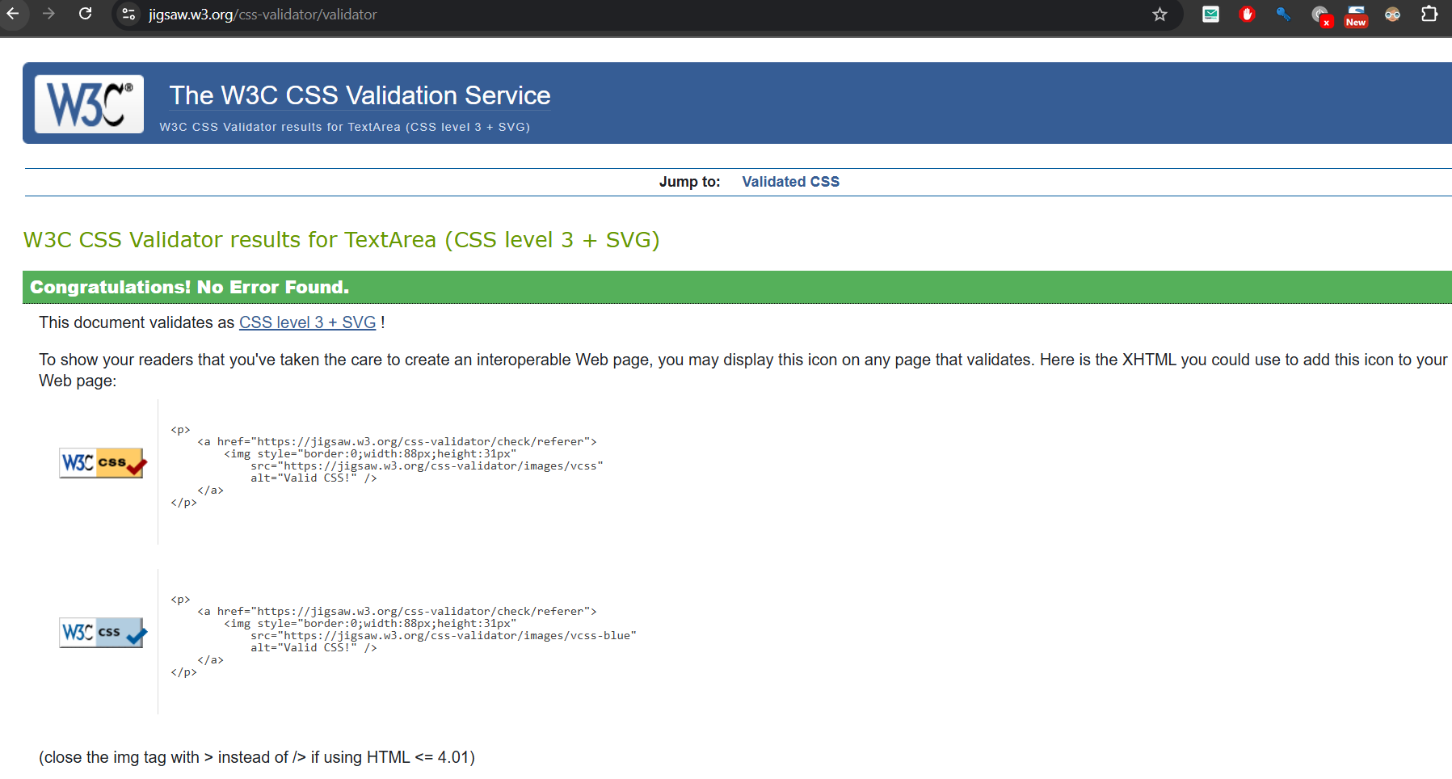

# form.css

## Code

/* General Styles */

body {

    font-family: Arial, sans-serif;

    background-color: #f5f7fa;

    color: #333;

    padding: 20px;

    margin: 0;

}

h1 {

    text-align: center;

    color: #00ced1;

}

/* Form Container */

form {

    max-width: 600px;

    margin: auto;

    padding: 20px;

    background: white;

    border-radius: 10px;

    box-shadow: 0 4px 6px rgba(0, 0, 0, 0.1);

}

/* Labels */

label {

    font-weight: bold;

    display: block; /* Ensures labels don't overflow */

    margin-bottom: 5px; /* Adds spacing between label and input */

}

/* Input Fields and Textarea */

input[type="text"],

input[type="email"],

textarea {

    width: 100%; /* Ensures inputs take up full width of the form */

    padding: 10px;

    margin: 5px 0 15px 0; /* Adds vertical spacing */

    border: 1px solid #ccc;

    border-radius: 5px;

    box-sizing: border-box; /* Includes padding and border in the element's total width */

}

/* Radio Buttons and Checkboxes */

input[type="radio"],

input[type="checkbox"] {

    margin-right: 10px; /* Adds spacing between radio buttons/checkboxes and labels */

}

/* Submit and Reset Buttons */

input[type="submit"],

input[type="reset"] {

    padding: 10px 20px;

    border: none;

    border-radius: 5px;

    background-color: #00ced1;

    color: white;

    cursor: pointer;

    margin-top: 10px; /* Adds spacing above the buttons */

}

input[type="submit"]:hover,

input[type="reset"]:hover {

    background-color: #00b3b3;

}

## Validation

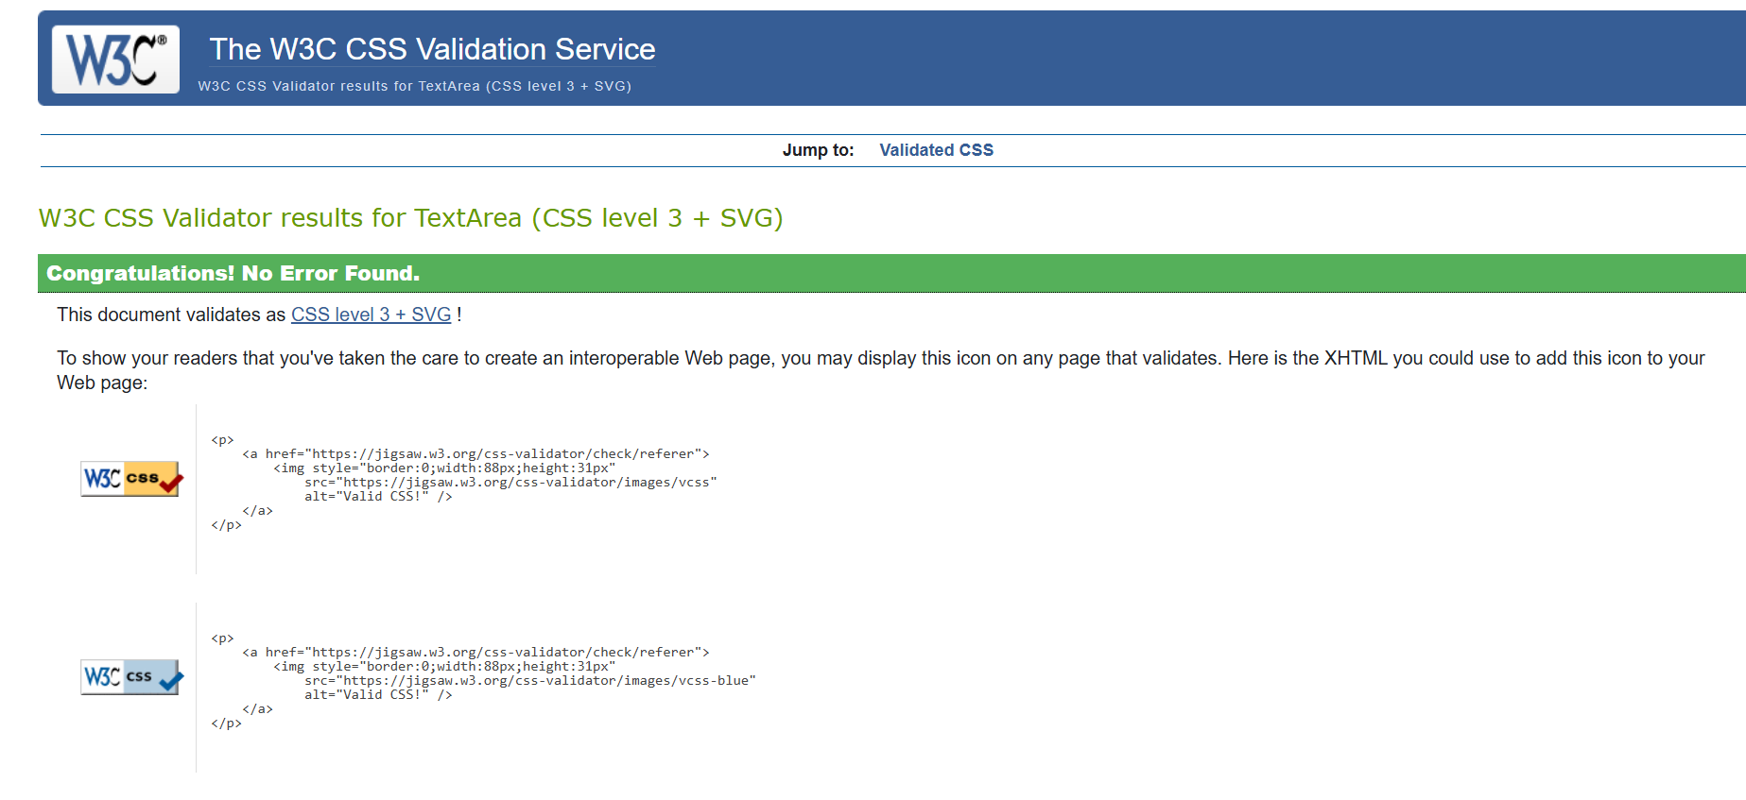

# References

MDN WEB DOCS. (2019, June 26). *CSS: Cascading Style Sheets*. MDN Web Docs. https://developer.mozilla.org/en-US/docs/Web/CSS

MDN Web Docs. (2018, December 10). *HTML: HyperText Markup Language*. MDN Web Docs. https://developer.mozilla.org/en-US/docs/Web/HTML

Moraes, F. (2015). *Home*. Html.com. https://html.com/

W3C. (n.d.). *The W3C CSS Validation Service*. W3.org. https://jigsaw.w3.org/css-validator/

W3C. (2013). *The W3C Markup Validation Service*. W3.org. https://validator.w3.org/

W3C. (2019). *Cascading Style Sheets*. W3.org. https://www.w3.org/Style/CSS/Overview.en.html

W3SCHOOLS. (2019). *CSS Tutorial*. W3schools.com. https://www.w3schools.com/css/

W3Schools. (2024). *HTML Tutorial*. W3schools.com. https://www.w3schools.com/html/